

Alert No 14/2015

This safety alert has been prepared by the RSTA. Completed forms for adding to the RSTA website should be submitted to Clive Mitchell [clive@rsta-uk.org](mailto:clive@rsta-uk.org) For further information regarding this safety alert please email Clive or phone 07557529410

**Safety Alert**

**Articulated Truck Tip-over**

At approx. 13:15 on the 3rd March 2015 driver Carl would have been on his fifth load of the day to the same site. Carl stopped at the stockpile, the loading shovel driver noticed the first bucket had filled the front of the trailer, he informed Carl and he checked the trailer. At this point he realised he had not completely tipped his last load off. Carl said he would use his on board weigher to check the weight in the trailer however this was not accurate so he decided to tip the whole load off. He did not tip at the designated tipping point, instead choosing to tip at the stockpile where he loaded. This was not challenged by anyone on site. During this tipping process in an area with a crossfall of 6 degrees the vehicle tipped over.

Carl has been driving HGV’s since 1984. Carl’s experience has been working with articulated low loaders and 8 wheel tippers. Carl was only on his second day driving an articulated tipper. (Incident day being his first day alone in the vehicle).



Alert No 14/2015

This safety alert has been prepared by the RSTA. Completed forms for adding to the RSTA website should be submitted to Clive Mitchell [clive@rsta-uk.org](mailto:clive@rsta-uk.org) For further information regarding this safety alert please email Clive or phone 07557529410

**Safety Alert**

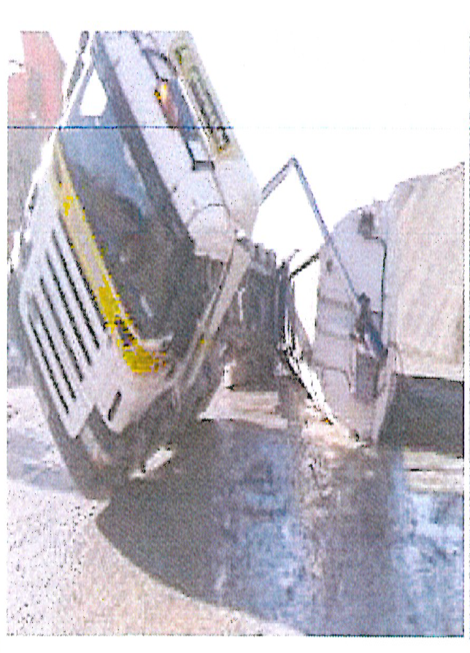

**Key Learnings**

* Ensure all drivers on site have received a site specific induction, this would have clearly stated the designated area & site specific tipping / loading procedures.
* Ensure that site specific inductions identify when a driver is new or inexperienced.
* Do not allow any vehicles to tip on a crossfall greater than 3 degrees. In this incident the area where the vehicle tipped was 6 degrees!
* Ensure all people on site are prepared to challenge.