**Create Outlook calendar event from an email**

**You can add an email to your calendar manually to create an event for your meeting.**

**Left click the email and drag the email down to the calendar icon in the bottom left of your screen.**

**The calendar event will open up at today’s date and time. You must change this to the date, stat time and duration of the meeting that has been emailed to you. Outlook will not automatically pick up this information.**

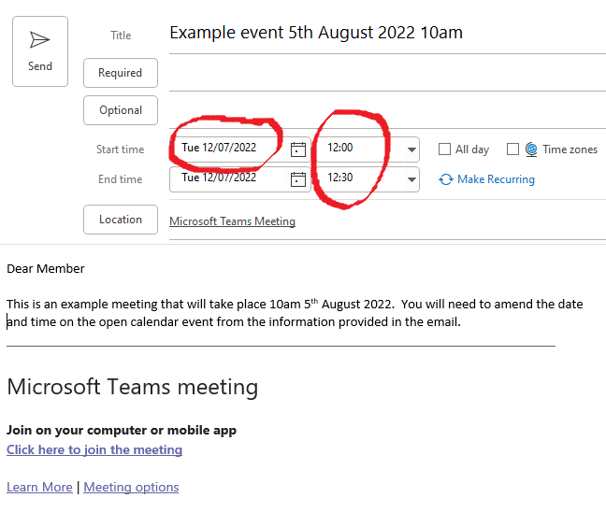

**Save your meeting.**

**Once you have saved the email as an item in your calendar, check you calendar to ensure you are happy with what you have saved.**