

**Safety Alert**

**Articulated Tipper Flipped**

During the 2011 **Surface Dressing** season an articulated tipper transporting a load of aggregate arrived at site and began to tip the body. When the body was two thirds raised a heavy gust of wind caught the trailer unit and flipped it onto its side. The site was unmanned (other than the delivery drivers) and was mainly level with slight camber in one area. The surface comprised of concrete

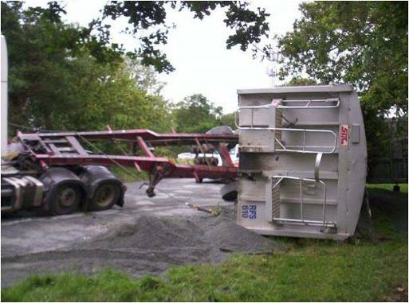



**Always follow the guidance of McQuillan Companies COP15 Surface Dressing Procedure**

**If unsure – Ask your Supervisor**

This safety alert has been prepared by the RSTA. Completed forms for adding to the RSTA website should be submitted to [Kathy@rsta-uk.org](mailto:Kathy@rsta-uk.org) further information regarding this safety alert please email Kathy or

phone 01902 824 325

Alert No 01/2016



**Safety Alert**

**Think When Reversing or Turning Round – It Can be a**

**Danger to YOUR LIFE and the Environment**

**Do’s and Don’ts**

* **Do** – Take care not to overbalance over the edge of a road formation. Examine edges for soft spots before starting work
* **Do** – Avoid gear changes on steep sections. Remember that a missed gear change may result in loss of control and the roller overturning
* **Don’t** rely on hand or parking brakes to maintain control
* **Do** – Park on the flat. If you must park on a slope, chock the roller
* **Don’t** – Climb onto a moving roller
* **Do** – Use 3 points of contact when getting in and out

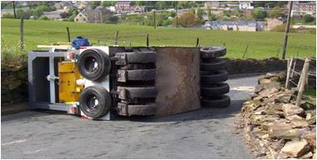

**PEDESTRIANS**

**Always maintain a Safe Distance**

**Make sure you are Visible to the Driver**

Alert No 01/2016

This safety alert has been prepared by the RSTA. Completed forms for adding to the RSTA website should be submitted to Kathy@rsta-uk.org further information regarding this safety alert please email Kathy or

phone 01902 824 325